Federal University of Rio de Janeiro

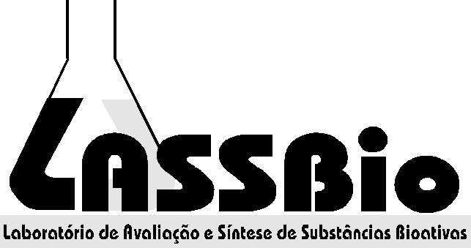

TERM OF AGREMENT AND CONFICENTIALITY /
NON-DISCLOSURE

I,___________________________________________(full name) with identification document _________________________ (passaport/identity card), as Post-Doc fellow, engaged in a research project of intellectual property of the Laboratory of Evaluation and Synthesis of Bioactive Substances (LASSBio) of the Federal University of Rio de Janeiro (UFRJ), at Health Science Center (CCS) sited at the ilha do Fundao, Rio de Janeiro state, working under the direct supervision of Full Professor ELIEZER J. BARREIRO, declare to be aware that the research project(s) represents scientific activities of research funding from LASSBio, and demands confidentiality, and may not be the object of disclosure initiated by myself, through any means, without prior express consent in writing provided by my research supervisor. I recognize that all documents related to the project(s), like spectrographs and other graphs of any nature, are property of LASSBio/UFRJ and therefore may not be disclosed in any way, and must be kept under my responsibility during my time at LASSBio and must be returned, in full, in the last day of my work, or at any other time when requested by the LASSBio coordinator.
By agreeing with the terms above in full, I subscribe, adding copy of the identity document mentioned above.
Rio de Janeiro,_______________________ 2015.

Signature:
Legible Name:
Address:

